**Sensor Lab (Course Code: ITL603)**

**Warehouse Monitoring System**

**T. E. Information Technology**

By

|  |  |
| --- | --- |
| Neel Mistry | 07 |
| Dyanaraj Vanniyar | 08 |
| Parth Rambhia | 09 |
| Pratham Muchhala | 10 |

Under Guidance of

**Dr. Nitika Rai**

Associate Professor



Department of Information Technology

St. Francis Institute of Technology

(Engineering College)

University of Mumbai

2022-2023

**CERTIFICATE**

This is to certify that the project entitled **“Warehouse Monitoring System”** is a bonafide work of **“Neel Mistry, Dyanaraj Vanniyar, Parth Rambhia and Pratham Muchhala” Roll Nos. 07, 08, 09 and 10** respectivelysubmitted to the University of Mumbai towards completion of mini project work for the subject of **Sensor Lab (Course Code: ITL603).**

**Dr. Nitika Rai**

**Supervisor/Guide**

**Dr. Prachi Raut**

**HOD-INFT**

Examiners

1.---------------------------------------------

2.---------------------------------------------

Date:

**DECLARATION**

I declare that this written submission represents my ideas in my own words and where others' ideas or words have been included, I have adequately cited and referenced the original sources. I also declare that I have adhered to all principles of academic honesty and integrity and have not misrepresented or fabricated or falsified any idea/data/fact/source in my submission. I understand that any violation of the above will be cause for disciplinary action by the Institute and can also evoke penal action from the sources which have thus not been properly cited or from whom proper permission has not been taken when needed.

--------------------------------------- ---------------------------------------

**Neel Mistry** **Dyanaraj Vanniyar**

--------------------------------------- ---------------------------------------

**Parth Rambhia** **Pratham Muchhala**

**ABSTRACT**

India is a vast and diverse country with a predominantly agrarian economy. Over 70% of the population is engaged in activities related to agriculture, making it a crucial sector for the country's economic growth and development. With the increasing amount of grain production, the need for efficient storage and transportation becomes crucial. However, grains are often sensitive to temperature and humidity, which can lead to spoilage and significant loss of food essentials. In this context, a new system has been developed to act as a precautionary measure and reduce the chances of grains going bad. The system consists of sensors that are installed in each storage unit and constantly monitor the temperature and humidity of their surroundings. These sensors provide real-time information about the storage conditions to the supervisors, allowing them to keep track of the conditions in the warehouse. Moreover, the system also acts as an alarm, alerting the supervisors as soon as the temperature or humidity threshold is crossed. By doing so, the system provides a line of defense that can prevent the spoilage of grains and minimize the loss of food essentials. The benefits of this system are numerous. Firstly, it helps warehouse owners gain a firm hold over their inventory by providing them with real-time information about the storage conditions. This allows them to take corrective measures promptly and prevent any loss of grains. Secondly, the system reduces the risk of spoilage and ensures the quality of the grains, thus increasing their shelf life. This, in turn, can lead to higher profits for the owners, as they can sell the grains at a premium price due to their superior quality. Moreover, this system has a positive impact on the overall food security of the country. By minimizing the loss of food essentials and ensuring that they reach the consumers in good condition, it helps to meet the growing demand for food in the country. The system also contributes to reducing food waste, which is a major problem in many countries. In addition, this system has environmental benefits as well. By reducing the amount of spoiled grains, it helps to conserve natural resources and reduces greenhouse gas emissions. This is because when grains spoil, they release methane, which is a potent greenhouse gas.

The development of this system is a significant step towards ensuring food security and sustainable development in India. It is a testament to the country's commitment to innovation and progress, and it has the potential to benefit millions of people by reducing food waste and increasing the quality of grains.

**Contents**

|  |  |  |
| --- | --- | --- |
| **Chapter** | **Contents** | **Page No.** |
| **1** | **INTRODUCTION** | 8 |
|  | **1.1 Introduction to Domain/Area and Motivation** | 8 |
|  | **1.2 Problem Statement and Objectives** | 9 |
|  | **1.3 Proposed Solution** | 9 |
|  | **1.4 Organization of the Report** | 9 |
| **2** | **LITERATURE REVIEW** | 10 |
| **3** | **SYSTEM DESIGN** | 11 |
| **4** | **IMPLEMENTATION AND RESULTS** | 15 |
| **5** | **CONCLUSION** | 22 |
|  | **REFERENCES** | 23 |

**List of Figures**

|  |  |  |
| --- | --- | --- |
| **Fig. No.** | **Figure Caption** | **Page No.** |
| 3.1 | System Design | 11 |
| 3.2 | Circuit Diagram - Transmitter | 13 |
| 3.3 | Circuit Diagram - Receiver | 13 |
| 4.1 | Flowchart of the system | 15 |
| 4.2 | Result - Working Model | 16 |
| 4.3 | Result – Temperature and humidity display | 16 |
| 4.4 | Result – Normal values | 17 |
| 4.5 | Result – Risen Humidity | 17 |
| 4.6 | Result - Warning | 18 |

**List of Tables**

|  |  |  |
| --- | --- | --- |
| **Table No.** | **Table Title** | **Page No.** |
| 1 | Literature Review | 10 |
| 2 | Component List | 12 |

**Chapter 1**

**INTRODUCTION**

* 1. **Introduction to Domain/Area and Motivation**

India is a country with a predominantly agrarian economy, where over 70% of the population is engaged in activities related to agriculture. With the increasing amount of grain production, the need for efficient storage and transportation becomes crucial. However, grains are often sensitive to temperature and humidity, which can lead to spoilage and significant loss of food essentials. Every year, an approximate of 40% of the food produced goes to waste due to various factors, one of them majorly being molds and improper infrastructure in warehouses. Grains are a staple food source for humans and animals, and monitoring their moisture content is crucial for ensuring their quality and safety. High humidity levels cause significant losses for businesses, as it damages food products and can lead to mold growth. To control mold growth, businesses are turning to humidity detection systems, which monitor and regulate humidity levels, thereby preventing loss due to spoilage of food grains.

In this context, a new system has been developed to act as a precautionary measure and reduce the chances of grains going bad. The system consists of sensors that are installed in each storage unit and constantly monitor the temperature and humidity of their surroundings. The information collected by these sensors is displayed to the supervisors, allowing them to keep track of the conditions in the warehouse. Moreover, the system also acts as an alarm, alerting the supervisors as soon as the temperature or humidity threshold is crossed. By doing so, the system provides a line of defense that can prevent the spoilage of grains and minimize the loss of food essentials. The benefits of this system are numerous. Firstly, it helps warehouse owners gain a firm hold over their inventory by providing them with real-time information about the storage conditions. This allows them to take corrective measures promptly and prevent any loss of grains. Secondly, the system reduces the risk of spoilage and ensures the quality of the grains, thus increasing their shelf life. This, in turn, can lead to higher profits for the owners, as they can sell the grains at a premium price due to their superior quality. Lastly, the system contributes to the overall food security of the country by minimizing the loss of food essentials and ensuring that they reach the consumers in good condition.

* 1. **Problem Statement and Objectives**

The aim of this project is to design a system that has the ability to act as a low cost wireless sensor which detects the temperature and humidity in warehouses, the system should constantly keep a track of the humidity and temperature, and alert the owners in case the values cross a certain threshold to avoid the spoilage of food grains.

The objectives of this project are:

* To design a model that can consistently and accurately detect fluctuations in temperature and humidity.
* To display the current humidity and temperature levels to the users.
* To alert stakeholders in case the humidity and temperature cross a certain threshold.
* To prevent grains and food items from spoiling due to changes in moisture levels.
  1. **Proposed Solution**

A system is necessary to monitor the temperature and humidity of the warehouse continuously. If the temperature or humidity exceeds a specific threshold, the system will alert the warehouse supervisor with the help of a buzzer and LED lights. Appropriate measures can then be taken to prevent damage to grains.

* 1. **Organization of the Report**

The organization of the report is as follows. Chapter 2 reports the literature survey. The proposed system design is presented in Chapter 3. Chapter 4 discusses the result and implementation steps and finally the conclusion in Chapter 5 followed by references.

**Chapter 2**

**LITERATURE REVIEW**

Table 1 includes the survey results from the research paper referenced and studied.

Table 1: Literature Review

|  |  |  |  |
| --- | --- | --- | --- |
| **REF. NO.** | **METHODOLOGY** | **ADVANTAGES** | **GAPS IDENTIFIED** |
| [1] | Design of Temperature and Humidity Detection System for a Material Warehouse Based on GM, 2020. | Use of ESP8266 chip to connect to Wi-Fi and DHT11 sensor to detect humidity and moisture. | Better sensors like SHT45 could be used to have more accurate and reliable readings. Better communication technologies can be used like ZigBee. |
| [2] | Impact of Using Electricity for Rural Warehouse Moisture Control System,2022. | Use of electricity to control moisture levels in rural warehouses. | Electricity issues in rural areas and increase in consumption of electricity leading to increasing cost. |
| [3] | Research on warehouse environment monitoring systems based on wireless sensor network, 2014. | Warehouse environment with monitor terminal, B/S web application and mobile devices. ZigBee and other wireless technologies used for data transmissions. | Name and details of the sensors are not provided and hence it cannot be commented on. |

**Chapter 3**

**SYSTEM DESIGN**

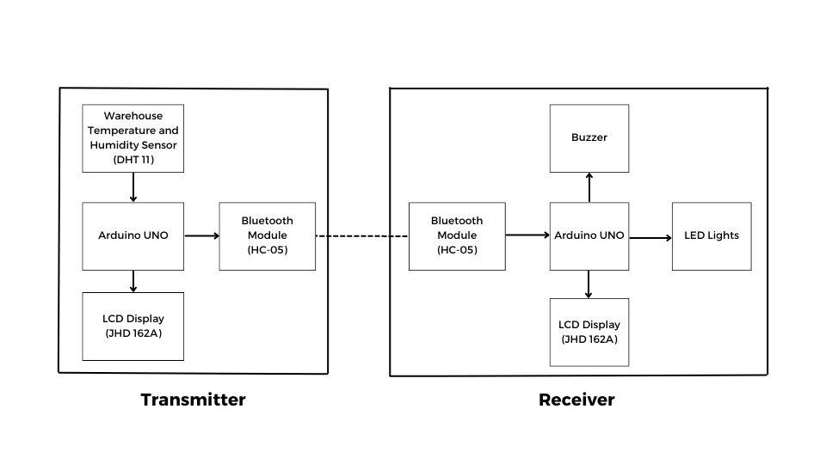

Fig 3.1: System Design

The block diagram depicted in Fig 3.1 presents the system design which shows the transmitter and receiver sections of the proposed system.

As shown in the block diagram, the DHT-11 Temperature and Humidity Sensor constantly monitors the temperature as well as humidity in the warehouse. The same monitored data is displayed on the LCD Display JHD 162A through the Arduino UNO. Whenever the temperature is in a proper advisable range, the Master Bluetooth Module HC05 sends ‘A’ to the Slave node. The Slave node, upon receiving ‘A’ displays the message as “Normal Temperature” on the LCD Display JHD 162A. Whenever the temperature moves past a certain threshold, the Master Node sends ‘B’ to the Slave node. Upon receiving ‘B’, the Buzzer starts to buzz, the Red LED starts to blink, and the temperature warning gets displayed on the LCD. As soon as the temperature becomes normal, the master sends ‘A’ to the slave, and the Red LED stops blinking, the Green LED gets turned on, and the buzzer stops buzzing. Similarly, if the humidity level crosses a certain threshold, ‘C’ gets transmitted through the master node. And upon receiving ‘C’, the buzzer and Red LED start to blink again, and the humidity warning is displayed on the LCD. Again, if the humidity is back to normal, ‘A’ gets transmitted, and everything gets back to normal.

**Hardware and Software Requirements**

Table 2 represents the approximate cost of components per unit as well as the number of units required in the model. The approximate cost of the working model came out to Rupees 2958.

**Software:**

* Arduino IDE

**Hardware:**

Table 2: Component List

|  |  |  |  |  |
| --- | --- | --- | --- | --- |
| **S. No.** | **Name of Component** | **Price per unit (INR)** | **No. of units** | **Total Price (INR)** |
| 1 | Arduino Uno | 750 | 2 | 1,500 |
| 2. | Bread board | 100 | 2 | 200 |
| 3. | HC-05 Bluetooth Module | 250 | 2 | 500 |
| 4. | JHD162A LCD | 270 | 2 | 540 |
| 5. | Jumpers Wires | 100 | 1 | 100 |
| 6. | DHT 11 Sensor | 100 | 1 | 100 |
| 7. | Buzzer | 10 | 1 | 10 |
| 8. | 3mm LED | 4 | 2 | 8 |
|  | TOTAL |  |  | **2958** |

**Circuit Diagram**

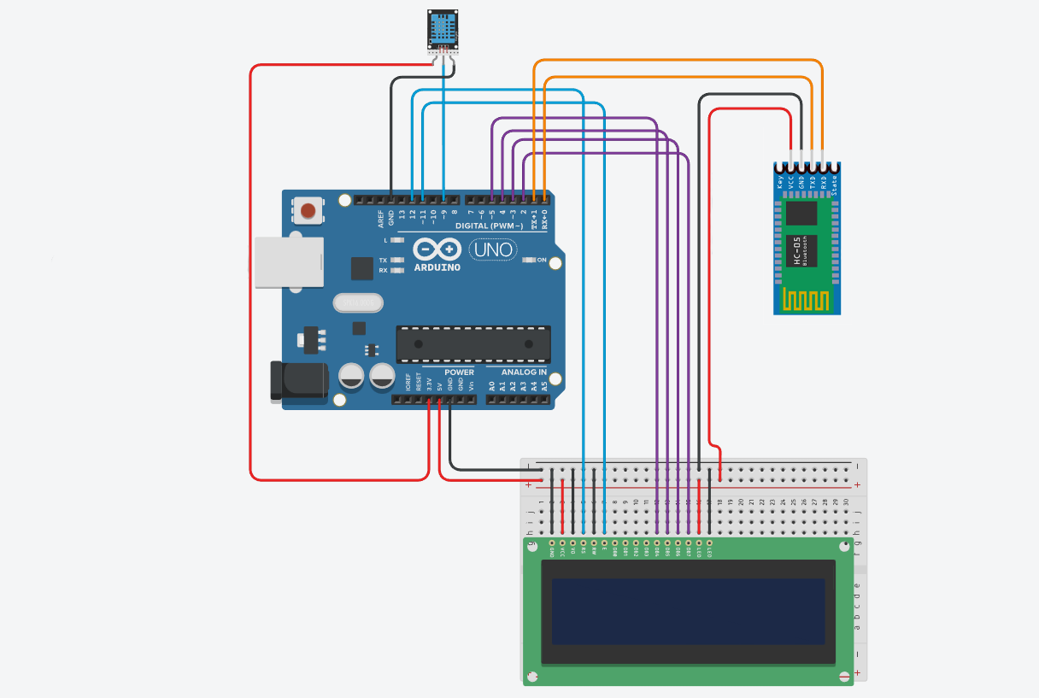

Fig 3.2: Circuit Diagram - Transmitter

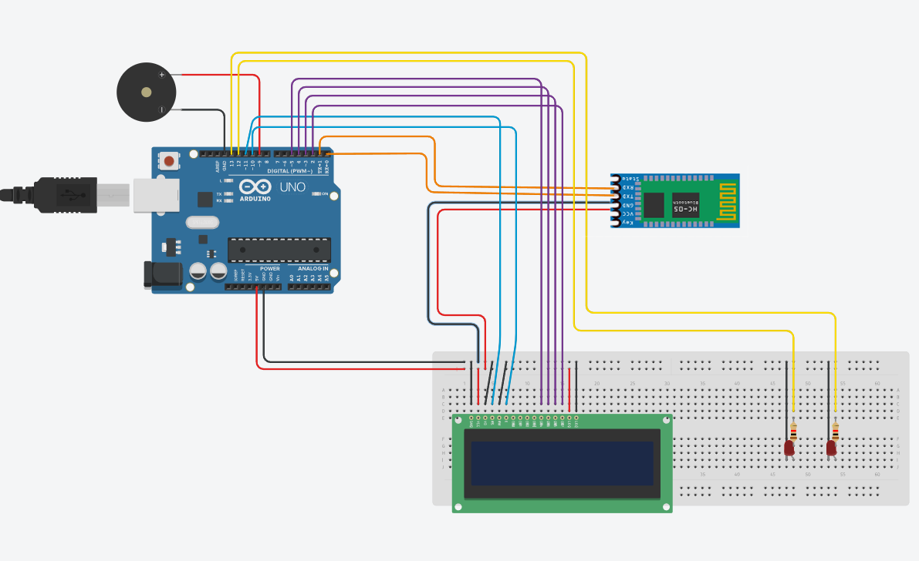

Fig 3.3: Circuit Diagram - Receiver

The circuit diagram depicted in Fig 3.2 and Fig3.3 presents the circuit design which shows the transmitter and receiver sections of the proposed system.

**Application Areas**

The system for monitoring temperature and humidity in a warehouse has a wide range of applications across various industries. Here are some potential application areas:

1. Food and Beverage Industry: The system can be used in food processing plants, storage facilities, and distribution centers to monitor the temperature and humidity levels of stored food products. This can help prevent spoilage and ensure that the food remains fresh and safe for consumption.
2. Pharmaceutical Industry: The system can be used in pharmaceutical manufacturing plants and storage facilities to monitor the temperature and humidity levels of medications, vaccines, and other sensitive products. This can help ensure that the products remain effective and safe for use.
3. Agriculture Industry: The system can be used in agricultural storage facilities such as silos, barns, and greenhouses to monitor the temperature and humidity levels of crops. This can help prevent spoilage and optimize the growth conditions of the crops.
4. Chemical Industry: The system can be used in chemical manufacturing plants and storage facilities to monitor the temperature and humidity levels of sensitive chemicals. This can help prevent degradation or reaction of the chemicals, ensuring they remain stable and effective.
5. Museums and Archives: The system can be used in museums and archives to monitor the temperature and humidity levels of stored artifacts, documents, and other valuable objects. This can help preserve the objects and prevent damage due to environmental conditions.
6. Data Centers: The system can be used in data centers to monitor the temperature and humidity levels of server rooms and other equipment rooms. This can help prevent overheating and equipment failure, ensuring uninterrupted service.
7. Hospitality Industry: The system can be used in hotels, resorts, and other hospitality businesses to monitor the temperature and humidity levels of storage rooms for linen, towels, and other supplies. This can help ensure that the supplies remain fresh and clean, providing a better experience for guests.

These are just some of the potential application areas of the system for monitoring temperature and humidity in a warehouse. The versatility of the system makes it a valuable asset for any business or industry that requires accurate environmental monitoring.

**Chapter 4**

**IMPLEMENTATION AND RESULTS**

**Flowchart**

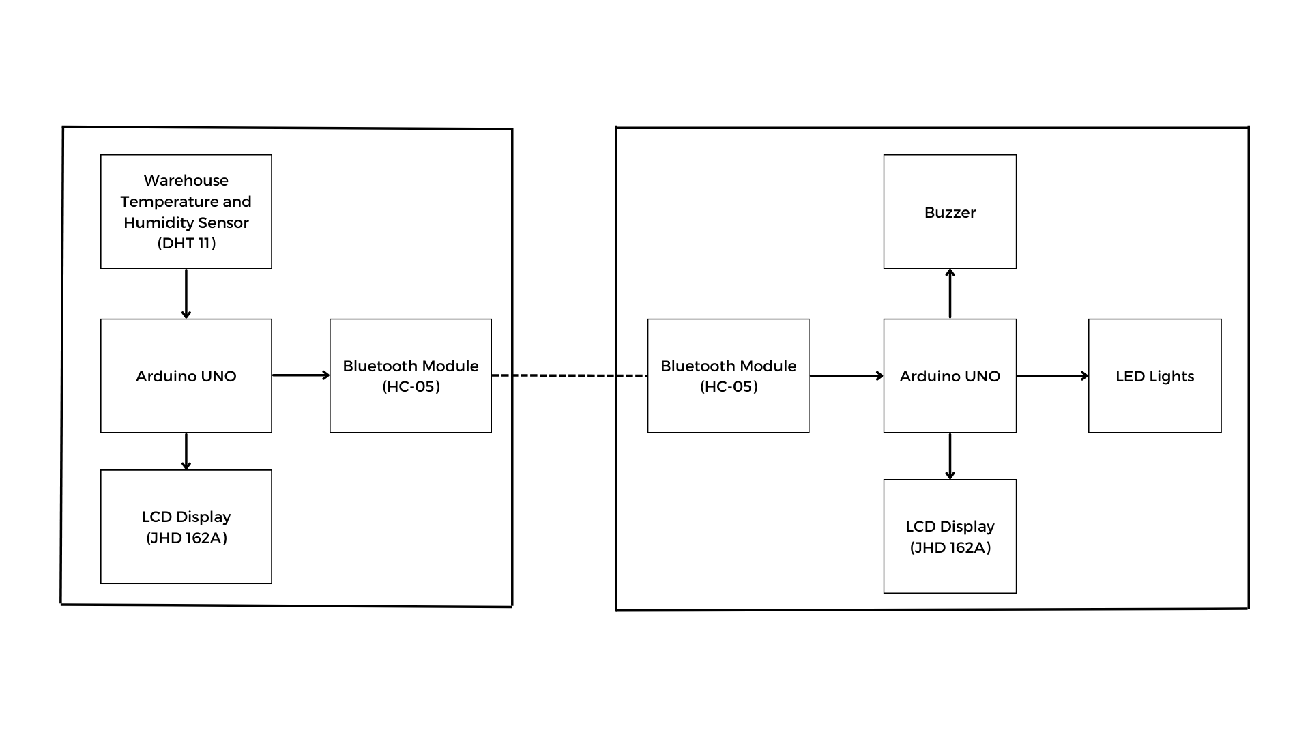

Fig 4.1: Flowchart of the system

The block diagram depicted in Fig 4.1 presents the system design which shows the transmitter and receiver sections of the proposed system.

As shown in the block diagram, the DHT-11 Temperature and Humidity Sensor constantly monitors the temperature as well as humidity in the warehouse. The same monitored data is displayed on the LCD Display JHD 162A through the Arduino UNO. Whenever the temperature is in a proper advisable range, the Master Bluetooth Module HC05 sends ‘A’ to the Slave node. The Slave node, upon receiving ‘A’ displays the message as “Normal Temperature” on the LCD Display JHD 162A. Whenever the temperature moves past a certain threshold, the Master Node sends ‘B’ to the Slave node. Upon receiving ‘B’, the Buzzer starts to buzz, the Red LED starts to blink, and the temperature warning gets displayed on the LCD. As soon as the temperature becomes normal, the master sends ‘A’ to the slave, and the Red LED stops blinking, the Green LED gets turned on, and the buzzer stops buzzing. Similarly, if the humidity level crosses a certain threshold, ‘C’ gets transmitted through the master node. And upon receiving ‘C’, the buzzer and Red LED start to blink again, and the humidity warning is displayed on the LCD. Again, if the humidity is back to normal, ‘A’ gets transmitted, and everything gets back to normal.

**RESULTS**

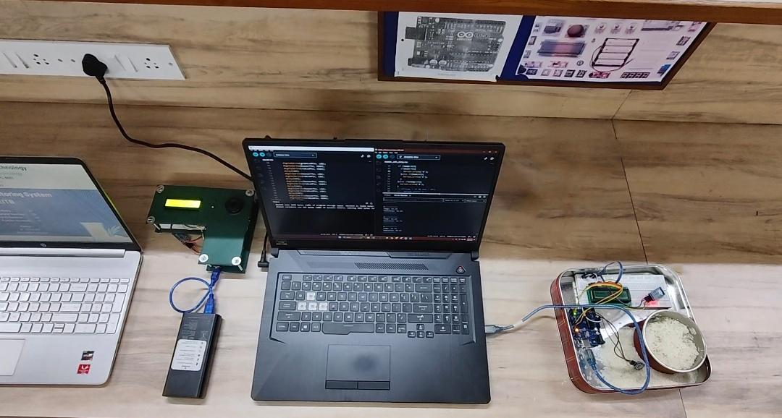

Fig 4.2: Result - Working Model

This image displays a complete working image of our system.

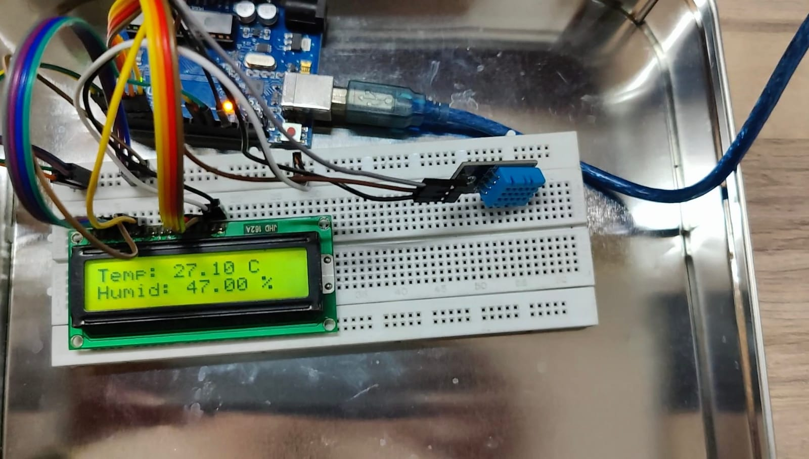

Fig 4.3: Result – Temperature and Humidity display

Fig 4.3 depicts the constant display of humidity and temperature of the surroundings

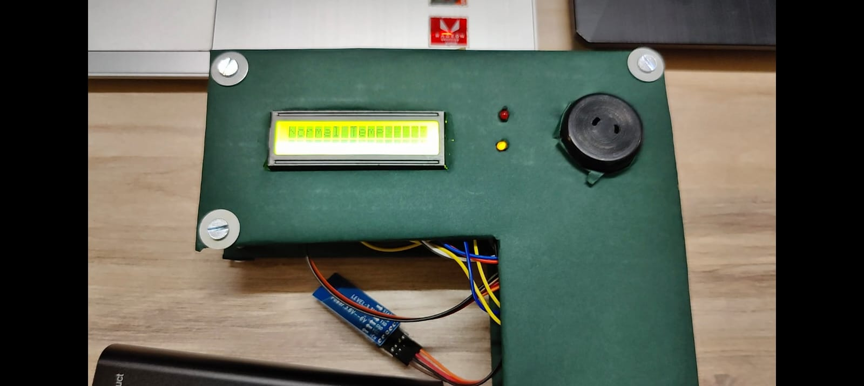

Fig 4.4: Result – Normal Values

Fig 4.4 depicts the message that is displayed on the receiver’s side when the data is under the given threshold.

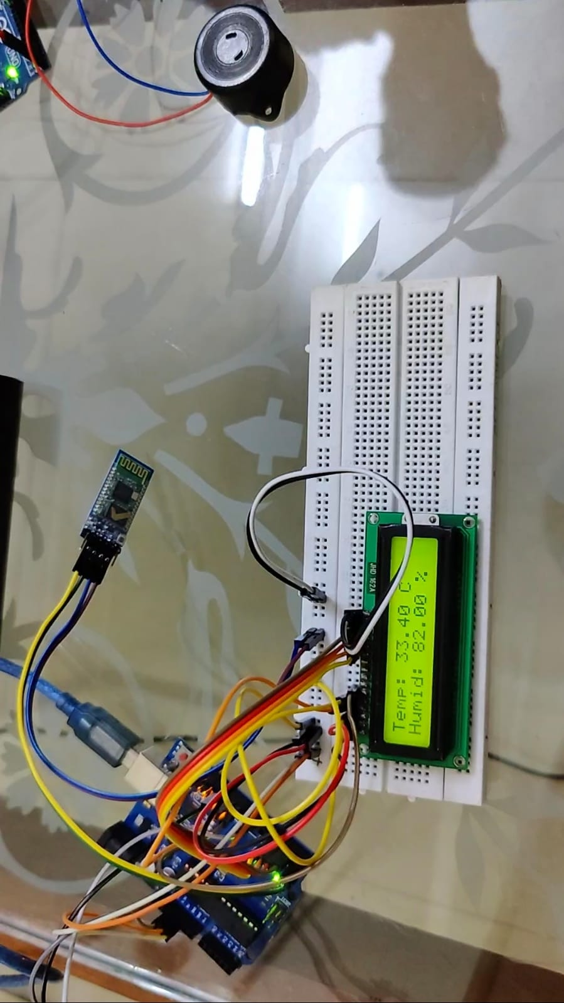

Fig 4.5: Result – Risen Humidity

Fig 4.5 depicts the rise in the humidity level which is more than the given threshold.

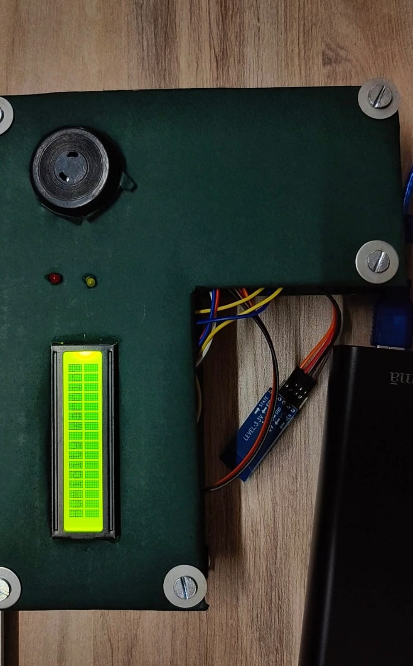

Fig 4.6: Result – Warning

Fig 4.6 depicts the warning message that is displayed when the given thresholds have been crossed.

**Code**

**Master Node:**

#include <DHT.h>

#include <LiquidCrystal.h>

#define DHTPIN 8

#define DHTTYPE DHT11

// Initialize the LCD display

LiquidCrystal lcd(12, 11, 5, 4, 3, 2);

DHT dht(DHTPIN, DHTTYPE);

void setup() {

Serial.begin(38400);

dht.begin();

// Serial.begin(9600);

Serial.println("Sending temperature and humidity data to HC-05 module");

pinMode(3, OUTPUT); // Configure pin 3 as an output pin

digitalWrite(3, HIGH); // Set pin 3 to HIGH to enable HC-05 communication

Serial.begin(9600); // HC-05 default speed in AT command mode

lcd.begin(16, 2);

lcd.setCursor(0, 0);

}

void loop() {

Serial.println("----------");

// Reading temperature and humidity data from the DHT11 sensor

float temp = dht.readTemperature();

float hum = dht.readHumidity();

Serial.println("Temp: " + String(temp));

Serial.println("Humidity: " + String(hum));

Serial.println("----------");

Serial.println("");

lcd.print("Temp: ");

lcd.print(temp);

lcd.print(" C");

lcd.setCursor(0, 1);

lcd.print("Humid: ");

lcd.print(hum);

lcd.print(" %");

delay(2000);

lcd.clear();

if (temp<30){

if(hum<70){

Serial.write('A');

}else if(hum>69){

Serial.write('C');

}

}else if(temp>29){

Serial.write('B');

}

else{

Serial.write('n');

}

delay(2000); // Wait for 2 seconds before sending again

}

**Slave Node**

#include <LiquidCrystal.h>

int buzzerPin = 9;

int buttonPin = 7;

const int redLedPin = 13;

const int greenLedPin = 12;

// Initialize the LCD display

LiquidCrystal lcd(11, 10, 5, 4, 3, 2);

void setup() {

Serial.begin(9600);

Serial.println("Ready to receive data");

pinMode(redLedPin, OUTPUT);

pinMode(greenLedPin, OUTPUT);

pinMode(2, OUTPUT); // Configure pin 2 as an output pin

digitalWrite(2, HIGH); // Set pin 2 to HIGH to enable HC-05 communication

pinMode(buzzerPin, OUTPUT);

Serial.begin(9600);

lcd.begin(16, 2);

lcd.setCursor(0, 0);

Serial.begin(9600); // HC-05 default speed in AT command mode

}

void loop() {

if (Serial.available()) {

char receivedChar = Serial.read();

if (receivedChar == 'A') {

lcd.print("Normal Temp");

delay(2000);

lcd.clear();

Serial.println("Normal Temperature");

digitalWrite(buzzerPin, LOW);

digitalWrite(greenLedPin, HIGH);

delay(2000);

} else if (receivedChar == 'B') {

Serial.println("WARNING! TEMPERATURE INCREASED!!");

lcd.print("Thermal Warning!!");

digitalWrite(greenLedPin, LOW);

digitalWrite(buzzerPin, HIGH);

digitalWrite(redLedPin, HIGH);

delay(500);

digitalWrite(buzzerPin, LOW);

digitalWrite(redLedPin, LOW);

delay(500);

digitalWrite(buzzerPin, HIGH);

digitalWrite(redLedPin, HIGH);

delay(500);

digitalWrite(buzzerPin, LOW);

digitalWrite(redLedPin, LOW);

delay(500);

digitalWrite(buzzerPin, HIGH);

digitalWrite(redLedPin, HIGH);

delay(500);

digitalWrite(buzzerPin, LOW);

digitalWrite(redLedPin, LOW);

delay(2000);

lcd.clear();

} else if (receivedChar == 'C') {

Serial.println("WARNING! HUMIDITY INCREASED!!");

lcd.print("Humidity Warning!!");

digitalWrite(greenLedPin, LOW);

digitalWrite(buzzerPin, HIGH);

digitalWrite(redLedPin, HIGH);

delay(500);

digitalWrite(buzzerPin, LOW);

digitalWrite(redLedPin, LOW);

delay(500);

digitalWrite(buzzerPin, HIGH);

digitalWrite(redLedPin, HIGH);

delay(500);

digitalWrite(buzzerPin, LOW);

digitalWrite(redLedPin, LOW);

delay(500);

digitalWrite(buzzerPin, HIGH);

digitalWrite(redLedPin, HIGH);

delay(500);

digitalWrite(buzzerPin, LOW);

digitalWrite(redLedPin, LOW);

delay(2000);

lcd.clear();

}

}else{

lcd.setCursor(4, 0);

lcd.print("NO DATA!");

delay(500);

lcd.clear();

}

}

**Chapter 5**

**Conclusion**

The proposed system for monitoring the temperature and humidity of a warehouse is an excellent example of how technology can be used to address critical problems faced by industries. By accurately monitoring these environmental factors, the system can alert the user if the conditions become unfavorable for storing food grains, and therefore, prevent spoilage.

Spoilage of food grains due to poor storage conditions is a common problem faced by the food industry. Inadequate temperature and humidity levels can lead to the growth of bacteria, mold, and other pathogens, which can render the grains unfit for human consumption. The proposed monitoring system can help mitigate this problem by providing real-time data on the conditions within the warehouse, allowing the user to take proactive measures to ensure the grains are stored in optimal conditions.

The use of a buzzer and LED indication to alert the user is an excellent feature of the system. This method of notification is both audible and visible, ensuring that the user is immediately notified of any issues. This allows for swift action to be taken, minimizing the risk of spoilage.

One of the most significant advantages of this monitoring system is that it can help reduce overall wastage of food, which, in turn, can increase profits for the owners. The cost of spoiled food can be significant, and by reducing this wastage, the owners can improve their bottom line. This can lead to a more sustainable business model and reduce the environmental impact of food waste.

While the system has room for upgrades, its ability to address a critical problem faced by the food industry makes it a valuable asset. Upgrades could include additional sensors for monitoring other environmental factors, such as air quality or light levels, or integrating the system with a remote monitoring platform for increased accessibility.

In conclusion, the proposed system for monitoring the temperature and humidity of a warehouse is an innovative solution to a critical problem faced by the food industry. By preventing spoilage, the system can help reduce food waste, increase profits, and create a more sustainable business model. The system's potential for upgrades makes it an excellent investment for any business looking to optimize their operations and reduce their environmental impact.

**References**

**RESEARCH PAPERS**

[1] G. Yi, J. Yang, M. Yanhui and G. Chao, "Design of warehouse monitoring system based on ARM platform," 2021 6th International Conference on Intelligent Computing and Signal Processing (ICSP), Xi'an, China, 2021, pp. 1287-1290, doi: 10.1109/ICSP51882.2021.9408826.

[2] H. Yuan, Z. Wang and L. Xia, "Design of Temperature and Humidity Detection System for a Material Warehouse Based on GM," 2020 IEEE 4th Information Technology, Networking, Electronic and Automation Control Conference (ITNEC), Chongqing, China, 2020, pp. 2516-2519, doi: 10.1109/ITNEC48623.2020.9085141.

[3] Q. Zhang, Y. Wang, G. Cheng, Z. Wang and D. Shi, "Research on warehouse environment monitoring system based on wireless sensor network," 2014 9th IEEE Conference on Industrial Electronics and Applications, Hangzhou, China, 2014, pp. 1639-1644, doi: 10.1109/ICIEA.2014.6931430.

**ONLINE REFERENCES:**

[4] https://circuitdigest.com/microcontroller-projects/interfacing-dht11-sensor-with-arduino

[5] https://www.electronicshub.org/dht11-humidity-sensor-arduino/

## Acknowledgment

We are thankful to our college **St. Francis Institute of Technology** for giving us this chance to gain exposure in solving real world problems and acquire practical knowledge and skill sets that will prove to be very crucial to our long-term career prospects. We would take this opportunity to express our sincerest gratitude to our esteemed Director **Bro. Shantilal Kujur**, our Principal **Dr. Sincy George** and our **HOD, Dr. Prachi Raut** for their encouragement, the direction that they give to our college and us students, and the facilities provided to us.

This project, and the research that we undertook, could not have been realized without the utmost support of our project guide **Dr. Nitika Rai**, who guided us every step of the way, starting from the conception of the project, right up to the execution of the finished solution.